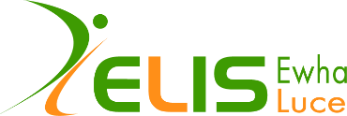
Letter of Recommendation
Ewha-Luce International Seminar for Women Graduate Students in STEM
from the US, Asia and Oceania.

PLEASE PRINT IN ENGLISH / OR IN KOREAN
Please provide the following information.
Name of Applicant:
Name of Referee:
Institution:
Please fill in the form and email it to womeninstem@ewha.ac.kr with the heading: [Letter of Recommendation: name of the applicant], by March 31 (Wed) 2021. The recommending email must be sent by the recommender themselves.

1. How long have you known the applicant? Please also briefly describe the context of your relationship with the applicant.

2. Please rate the applicant’s competence on the following:
 | Truly Exceptional | Outstanding | Good | Average | Below Average | No Basis to Evaluate
1) Academic Ability
2) Self-Motivation
3) Emotional Maturity
4) Working with Others
5) Communication
6) Resourcefulness and Initiative
3. Please evaluate the applicant’s quality as a next generation leader, her personal relationship with friends and professors, her involvement in on and off campus community, and any other outstanding characteristics that may prove her capacity to contribute to the scientific community.

I certify that all information provided in this statement is true to the best of my knowledge, and is made in good faith. I understand that statements on this form may be subject to a verification process and I agree to provide supporting documents or information if requested.

ABOUT THE RECOMMENDER:
Name:
Institution:
Position/Title:
Email:
Phone:

Signature Date

The Ewha-Luce International Seminar ensures the privacy of the participants, and any form of personal information will be used only for the sole purpose of this seminar and will be destroyed thereafter.

